 | 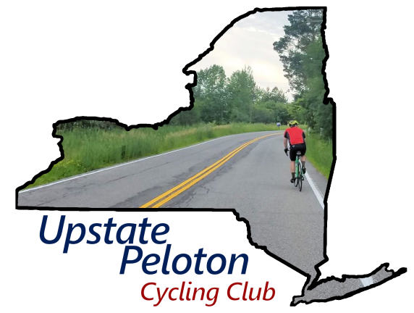
Please donate to the American Diabetes Association
Tour de Cure: Capital Region

I'm riding in the Tour de Cure and raising funds for the American Diabetes Association (ADA). I have two diabetic family members; Having witnessed one go into diabetic shock and come close to dying, I want to help the ADA fight back with research, education, and advocacy.

I would appreciate your support in reaching or exceeding my fundraising goal. Every dollar you donate will go directly towards funding critical research, diabetes prevention programs, and community outreach initiatives. Your contribution, no matter the size, will profoundly impact the lives of 38 million Americans affected by diabetes.

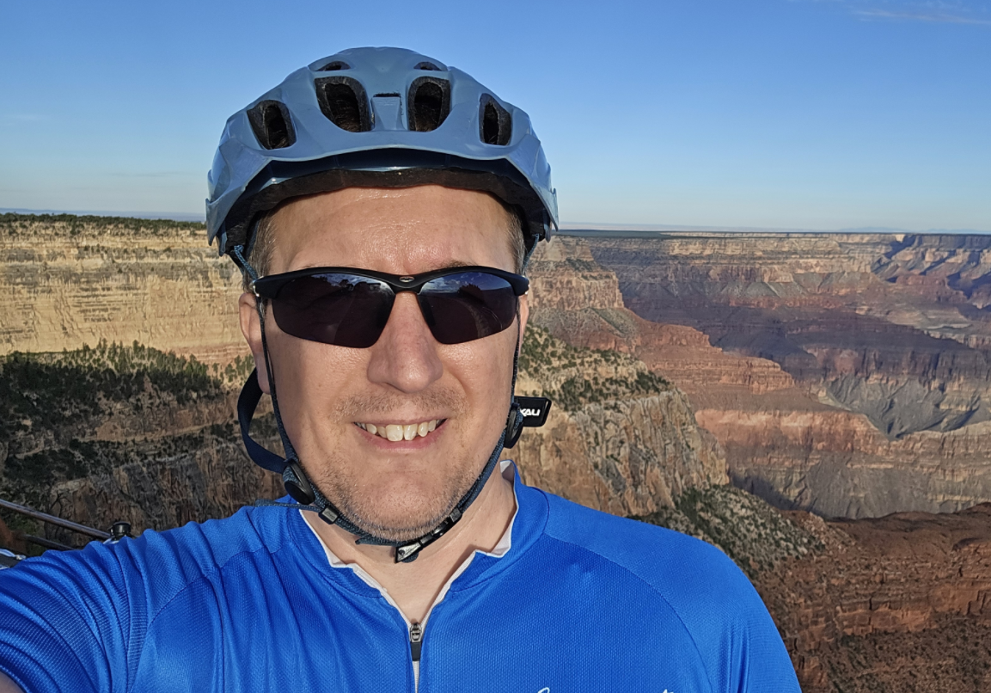  Chris Glockler | I’m cycling 100km  on 6/13/2026 to benefit  American Diabetes Association
  Please make a donation
  Scan QR code with your phone
  
  https://tour.diabetes.org/participant/ChrisGlockler

Since 1991, the Tour de Cure® has served as the American Diabetes Association's (ADA) signature cycling and fundraising event that promotes their mission and healthy living. The Tour is the moment for organizations and individuals to come together and show our community how much we care - and how much we'll do to end diabetes for good. By donating, you'll help American Diabetes Association increase awareness, provide vital programs, fund lifesaving research, and work toward a cure.

