  FUNDRAISER | 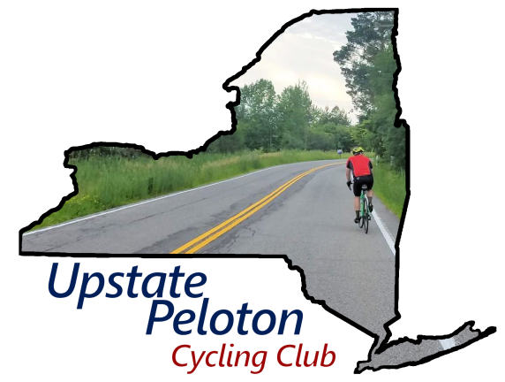

I'm riding in the Tour de Cure and raising funds for the American Diabetes Association (ADA). I want to help the ADA fight diabetes with research, education, and advocacy.

I would appreciate your support in reaching or exceeding my fundraising goal. Every dollar you donate will go directly towards funding critical research, diabetes prevention programs, and community outreach initiatives. Your contribution, no matter the size, will profoundly impact the lives of 38 million Americans affected by diabetes.

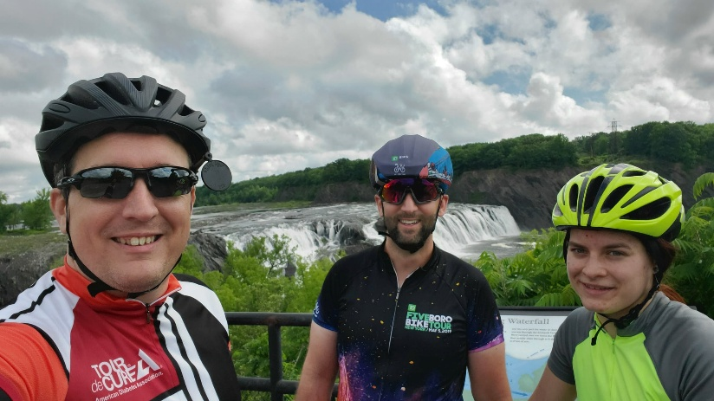  Upstate Peloton  Cycling Club rider | I’m cycling  on 6/13/2026 to benefit  
  Please make a donation
  Scan QR code with your phone
  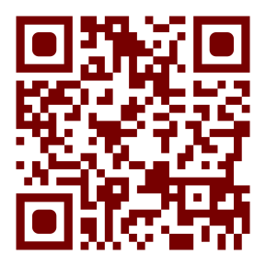
  www.upstatepeloton.com/TDC/?donate

Since 1991, the Tour de Cure® has served as the American Diabetes Association's (ADA) signature cycling and fundraising event that promotes their mission and healthy living. The Tour is the moment for organizations and individuals to come together and show our community how much we care - and how much we'll do to end diabetes for good. By donating, you'll help American Diabetes Association increase awareness, provide vital programs, fund lifesaving research, and work toward a cure.

Notes/Suggestions:
- Colored Border is in case you want to throw in an 8x10 frame (which is cheaper than 8.5x11)
  - Red border is fine for 8.5x11 frame since that’s the official color of ADA
- Personalize the page - suggestions
  - Between the two bolded sentences after the red block, insert your personal reason for fundraising
  - Update barcode URLs to point directly to your page
    - Ideally, the URL should point directly to the diabetes web site and be short
    - tip: create a vanity URL in your profile. Go to: Portal Your Page Settings
    - You can capture the QR code from the DonorDrive app QR a code generator:
https://www.qrcode-monkey.com/#url
    - Change the URL under the QR code to match
  - Change the image to an image of you riding
  - Change the name under the image
- Use Glossy Photo paper and “best photo” (or whatever your printer driver calls it)
- Save paper, only print the first page

