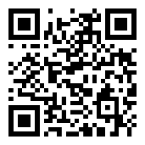  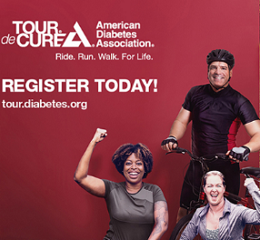  Have you signed up for the Upstate NY Tour de Cure?  Sat June 12, 2027  Ellms Family Farm  Bicycle Distance:  10, 32, or 62 miles  Registration Fee: $30  Fundraising Minimums  $250 to participate in-person  For details about joining our team or to donate: www.upstatepeloton.com/TDC | 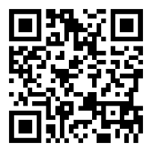  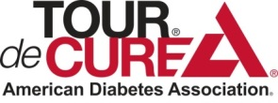  Over 40 million Americans are living with diabetes, Every 21 seconds someone in the U.S. is diagnosed with diabetes.  Help us find the cure! Donate to our team by scanning the barcode on your phone.  www.upstatepeloton.com/TDC
Instructions
- Customize the top row however you want, e.g.
  - adjust your personal URL- set up in your TDC profile ; replace circled URL with yours
  - replace text with personal reason why you’re fundraising (friend/family/etc)
  - use https://www.qrcode-monkey.com/# to update URL in QR code
- Copy/paste the top row to fill out the table/page
- Delete these instructions & any rows on a 2nd page
- Print front and back onto business card paper so that each card will have a separate image front/back

